

Orbit Flow 40 User Guide

21st May 2026
Version 0.1

Contents
1 Introduction 3
2 How Is the Orbit Flow 40 Used? 3
2.1 Remote Mode 3
3 In the Box 4
4 Features 4
5 Orientation 4
5.1 Top view 4
5.2 Side view 5
5.3 Front view 5
5.4 8-Dot Braille Cells 5
6 Getting Started 5
6.1 Power Supply 5
6.2 About Menus and File Names 6
6.3 Entering and Exiting Menus 6
6.4 Device Operational Modes 6
7 The Menu 6
7.1 Menu Options 7
7.1.1 Version 7
7.1.2 Serial Number 7
7.1.3 Emulate (HID-Braille) 7
7.1.4 Sleep timeout (min) (10) 7
8 Remote Mode 8
8.1 USB 8
8.1.1 Human Interface Device (HID) – Orbit 8
8.1.2 Human Interface Device (HID) – Braille 9
8.2 Windows PCs 9
8.2.1 Non-Visual Desktop Access (NVDA) 9
8.2.2 Job Access with Speech (JAWS) 10
9 Reboot the Device 11
10 Device Upgrade Procedure 11
10.1 Device Firmware Upgrade 11
10.1.1 Download firmware package 11
10.1.2 Using the Windows PC Upgrade Utility 12
11 Orbit Flow 40 Cleaning Tips 14
12 General Specifications 14
13 Appendices 14
13.1 Appendix A - Computer Braille Chart 14
14 Revision History 17

Introduction
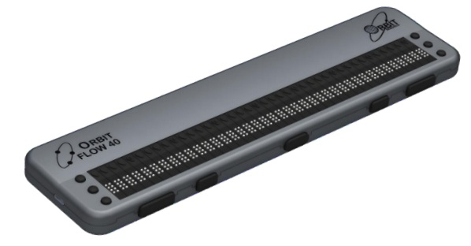
The Orbit Flow 40 is a portable, refreshable braille display with the following features:
- A line of 40 braille cells with pins that arrange into the required pattern to accurately represent any six- or eight-dot braille code, in any language, and for any discipline.
- Cursor routing buttons
- Remote connectivity to PCs and mobile devices for use with a screen reader

How Is the Orbit Flow 40 Used?

Remote Mode
Connect the device to a computer or mobile device with a screen-reader and then do one of the following:
- Read commercially available titles on Kindle™, Adobe® Digital Editions, or Apple Books® application programs.
- Employ any accessible technology for browsing, utilities, and education.
- The screen reader translates text into Braille code of choice.

In the Box
The Orbit Flow 40 package typically includes the following items:

- The Orbit Flow 40 unit
- USB Type-C cable
- A Quick-Start guide in large-print

Features
The Orbit Flow 40 has the following features:
- 40 refreshable eight-dot braille cells that can display 6-dot as well as 8-dot braille symbols
- A cursor routing button above each braille cell
- Three left and three right panning input keys
- Four thumb keys and one home key
- USB Type-C communication port

Orientation
The orientation of buttons, keys, and cells is important for understanding how Orbit Flow 40 operates and how you input and receive information on your braille display.

To begin with, place the device on a flat surface in front of you with the row of braille cells closest to you. This is the proper operational orientation.

Top view
When properly oriented, the braille display is closest to you. The panning keys are located vertically at each end of the braille display.
Left side, from top to bottom: Left pan upper (LPU), Left pan middle (LPM) and Left pan lower (LPL) are available.
Right side, from top to bottom: Right pan upper (RPU), Right pan middle (RPM) and Right pan lower (RPL) are available.
There are 40 cursor routing keys available above each braille cell.

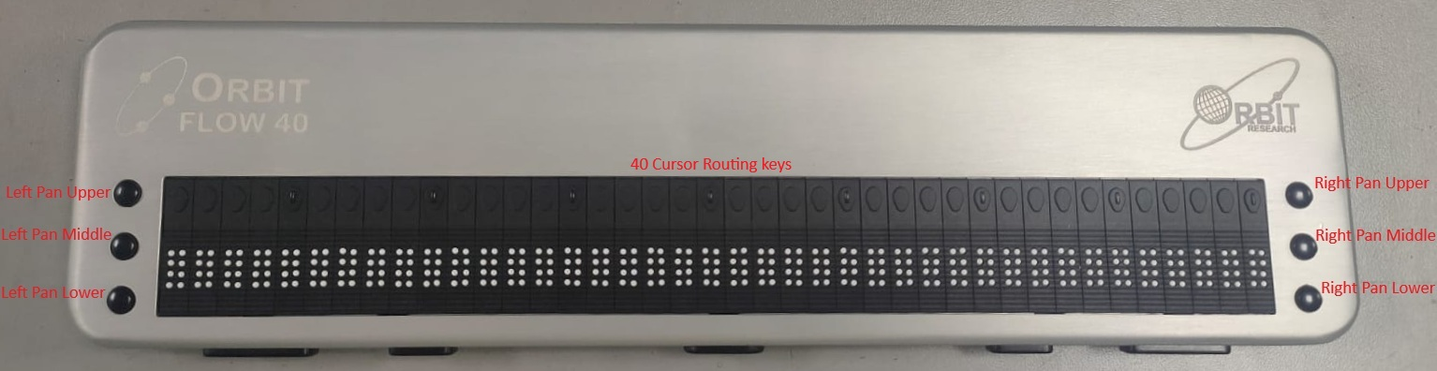

Side view
On the left side of the device, USB Type-C is present.

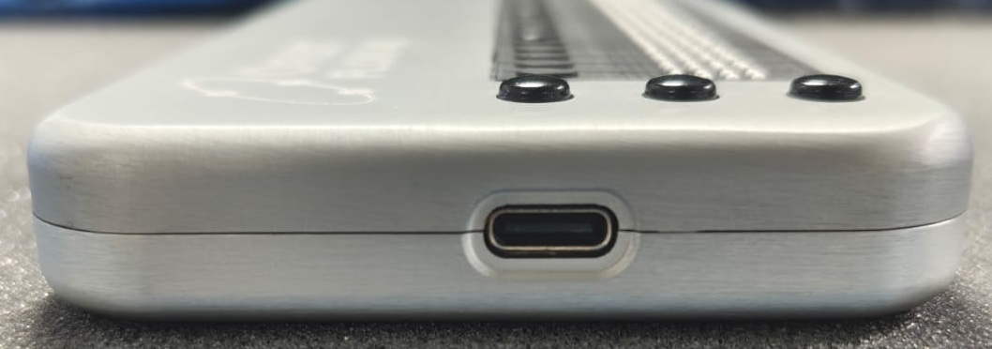

Front view
At the frontside of the device, is the four thumb keys with the one Home key.
The keys position from left to right are as follows:
Thumb key 1, Thumb key 2, Home key, Thumb key 3 and Thumb key 4
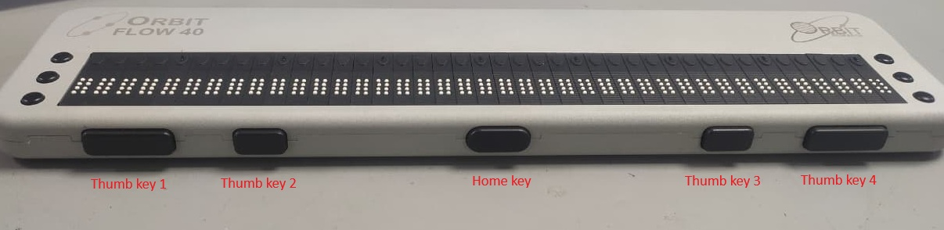

8-Dot Braille Cells
The Orbit Flow 40 is a six-dot braille device with two additional dots below Dot 3 and Dot 6. These two additional dots are Dot 7 and Dot 8, which are used to indicate capitalization while reading the file in 8 dot mode. These dots also indicate text with attributes or accent marks or a cursor. Their exact use depends on the application you use with the display.

Getting Started
Orbit Flow 40 supports Remote mode functionality. The device works like a braille display and needs to be connected to a computer or other host with a screen reader.

Power Supply
The Orbit Flow 40 connects to a computer or other host using a standard USB-A to USB-C cable. When connected, it receives power directly from the host device and communicates through the same USB connection. The device does not have an internal battery and does not support any external power supply or adapter. It operates only while it is connected to a powered host. Once disconnected, the device turns off immediately. No alternative power connection methods should be used.

When device powered on, but no screen reader is connected, the device shows the product name, firmware version, and current protocol.
For example: “Orbit Flow 40 V00r01 HID-Braille”.
When a screen reader is connected, screen reader output data will be shown.

About Menus and File Names
The Orbit Flow 40 shows internal menus settings according to the English Computer Braille language in the menu.

Entering and Exiting Menus
- To Open the menu, press Thumb key 1 + Thumb key 4
- To Exit and save the menu, press Home key
- To Move through the menu items, press the Thumb key 1 or Thumb key 4
- To See choices within a menu item, use the Thumb key 2 or Thumb key 3

Device Operational Modes
Orbit Flow 40 works with Remote mode functionality.

Remote mode allows you to connect the Orbit Flow 40 to iPhone®, iPad®, and Android™ mobile devices, as well as desktop computers via USB. In Remote mode, Orbit Flow 40 acts as an input and output device for the remotely connected host via USB. See the Remote Mode section of this document for more information.

Remote mode supports two different screen reader protocol modes Orbit Braille (HID Orbit) and Standard HID Braille.

You can switch between the 2 modes via key combinations not conflicting with any screen reader:
- HID Braille – Thumb key 1 + Thumb key 4 + CR 1
- HID Orbit – Thumb key 1 + Thumb key 4 + CR 2

The Menu
The Orbit Flow 40 provides a menu for configuring settings and viewing device information such as version and serial number.
To open the menu, press Thumb Key 1 + Thumb Key 4 simultaneously. When the menu opens, “Orbit Flow 40” is displayed as an indication.
You can navigate through the menu options using Thumb Key 1 and Thumb Key 4. The currently selected menu item is shown on the display.
To change a selected option, use Thumb Key 2 and Thumb Key 3.
Pressing the Home button saves any changes and exits the menu.

Menu Options
Some of the Menu options have a default setting (indicated in the list below). The menu settings is shown in US computer braille (8 dot) only.

- Version
- Serial No.
- Emulation (HID-Braille)
- Sleep timeout (min) (10)

Version
The Version item in the menu displays the version number of the software on your device. You may need the version number when talking to Customer Service. For the latest version of software, refer to the website.

Serial Number
The Serial Number item in the menu shows the serial number of the device you are using. This number is useful for service and warranty purposes.

Emulate (HID-Braille)
The Emulation option allows you to choose how the device appears to Host screen reader applications. If HID-Braille Emulation mode is selected, the Orbit Flow 40 appears as a Standard HID Braille display. If Emulation mode is HID-Orbit, it appears as Orbit Reader 40.

The default setting for Emulation mode is HID-Braille.

Sleep timeout (min) (10)
When the Orbit Flow 40 remains inactive for a period of time, the braille display automatically turns off to save power. The available sleep timeout settings are: OFF, 1, 2, 5, 10, 20, and 60 minutes. If the sleep timeout is set to OFF, Orbit Flow 40 will not enter sleep mode and will remain active continuously.

Remote Mode
Orbit Flow 40 connects with host devices (i.e., computers, phones, tablets) to provide braille input/output to that device. The host device must be running software that supports braille.

- Windows PCs - JAWS®, NVDA, Windows Narrator, System Access
- Mac® computers and iOS® devices - VoiceOver
When you use the Orbit Flow 40 as a display for other hosts, the screen reader on that host device provides translation and other braille settings. Refer to documentation for the specific screen reader you are using.

The only hotkeys used with Remote mode that are not sent to the remote device are as follows:
- Pressing Thumb key 1 + Thumb key 4 opens the Orbit Flow 40 Menus.
- Pressing Thumb key 1 + Thumb key 4 + CR 1 enables the HID Braille mode.
- Pressing Thumb key 1 + Thumb key 4 + CR 2 enables the HID Orbit mode.

USB
Universal Serial Bus (USB) is a technology that makes connecting devices with hosts easy. It provides some advantages over Bluetooth because it is both faster and charges the Orbit Flow 40 simultaneously.

The Orbit Flow 40 supports two kinds of USB connections (all with the same cable available in the box.)
- HID-Orbit
- HID-Braille (recommended)

Human Interface Device (HID) – Orbit
When using the Orbit Flow 40 with a screen reader that supports HID Orbit, follow these steps:
- Connect Orbit Flow 40 with USB. Orbit Flow 40 displays the current Emulation mode.
- If Emulation mode is not HID Orbit, press Thumb key 1 + Thumb key 4 + CR 2. "-- HID Orbit" is displayed.
- Start the screen reader. Orbit responds by displaying what the screen reader is showing.

Key mapping with HID-Orbit
When HID-Orbit is being used, the keymap works as follows:
- Thumb key 1 – pan backward
- Thumb key 2 – d-Pad up
- Thumb key 3 – d-Pad down
- Thumb key 4 – pan forward
- Home key – d-Pad center
- Left pan upper (LPU) key – d-Pad up
- Left pan middle (LPM) key – Pan left (backward).
- Left pan lower (LPL) key – d-Pad down
- Right pan upper (RPU) key – d-Pad up
- Right pan middle (RPM) key – Pan right (forward)
- Right pan lower (RPL) key – d-Pad down
- Cursor routing keys – move cursor on Braille display

Human Interface Device (HID) – Braille
When using Orbit Flow 40 with a screen reader that supports HID Braille, follow these steps:
- Connect Orbit Flow 40 with USB. Orbit Flow 40 displays the current Emulation mode.
- If Emulation mode is not HID Braille, press Thumb key 1 + Thumb key 4 + CR 1. "-- HID Braille" is displayed.
- Start the screen reader. Orbit responds by displaying what the screen reader is showing.

Key mapping with HID-Braille
When HID-Braille is being used, the keymap works as follows, when sending HID descriptors to screen readers:
- Thumb key 1 – Braille pan left
- Thumb key 2 – Braille d-pad up
- Thumb key 3 – Braille d-pad down
- Thumb key 4 – Braille pan right
- Home key –This will be used as a “home” command with various screen reader key mappings we will make and also on iOS and Android by default.
- Left pan upper (LPU) key – Braille rocker up
- Left pan middle (LPM) key – Braille pan left
- Left pan lower (LPL) key – Braille rocker down
- Right pan upper (RPU) key – Braille rocker up
- Right pan middle (RPM) key – Braille pan right
- Right pan lower (RPL) key – Braille rocker down
- Cursor routing keys – move cursor on Braille display

Windows PCs

Non-Visual Desktop Access (NVDA)
Currently, Orbit Flow 40 is not supported by NVDA with HID Orbit. You must set Orbit Flow 40 to emulate HID Braille on the menu. Go to the NVDA Preferences menu and select Braille Settings from the list. From the braille display drop-down menu, select "Standard HID Braille Displays" and click OK.

NVDA turns ‘On’ braille output when it is configured for the display. To turn ‘Off’ braille support, select "No Braille" from Braille Display options in the Braille Settings menu.

Job Access with Speech (JAWS)
To use Orbit Flow 40 with JAWS, you need to install a specific driver available here http://www.orbitresearch.com/support/orbit-reader-40-support/

For JAWS versions older than 24, you must use the HID Orbit emulation mode on the Orbit Flow 40.

To connect the Orbit Flow 40 via USB, follow these steps:
- Start or restart JAWS.
- Insert + J to bring up the JAWS menu.
- Press Enter on Options.
- Down Arrow to Braille and press Enter.
- Tab to Add and press Enter.
- If HID Orbit mode is enabled, Arrow Up or Down to Orbit Reader 40 and press Space to check the box and select it.
If HID Braille mode is enabled, Arrow Up or Down to HID Braille display and press Space to check the box and select it.
- Tab to the Next button and press Enter.
- Select USB.
- Tab to the Next button and press Enter.
- Select Orbit Reader 40 as a primary device.
- Tab to the Finish button and press Enter.
- Restart JAWS.
To turn off braille support, follow these steps:
- Insert + J to bring up the JAWS menu.
- Press Enter on Options.
- Down Arrow to Braille and press Enter.
- Up Arrow to No Braille Display.
- Tab to Ok and press Enter.
- Restart JAWS.
Note: For a longer description of any of the following commands, turn JAWS keyboard Help ‘on’ by pressing Insert + 1 and type the command. Quickly type the command twice to get an even longer description. Press Insert + 1 again to exit the JAWS keyboard Help mode.

Reboot the Device
If the Orbit Flow 40 suddenly does not respond to button presses, then you may try rebooting the device by pressing the Right Pan lower (RPL) key + Thumb key 3 or you can disconnect the USB cable and re-connect it again.

Device Upgrade Procedure

Device Firmware Upgrade
New versions of the firmware for the Orbit Flow 40 are released from time to time, containing improvements, bug fixes, and new features. This section describes the procedure for updating the Orbit Flow 40 firmware.

You can upgrade the firmware of the Orbit Flow 40 using a Windows PC and a USB cable. The USB upgrade method requires a Windows PC, but the upgrade process is simple and quicker.

There are two parts to the upgrade procedure:
- Download the firmware package
- Upgrade the Orbit Flow 40
The process for downloading the firmware package is common to either upgrade method.

Download firmware package
To download a Firmware Upgrade Package for the Orbit Flow 40:
- The latest firmware is not available on the website. You can request it by writing to us at techsupport@orbitresearch.com
- Select Orbit Flow 40 Firmware Upgrade Package vB0.01.00.XXrYY.
- Save the zip file to your PC.
When the download is complete, follow these steps:
- Open the folder on your computer where the firmware zip file was downloaded. This is usually your Downloads folder.
- Right-click on the file and choose "Extract all" OR select the file by arrowing to it, pressing the application key and choosing "Extract All" from the Context menu.
- Follow the dialog steps to extract the zip file to a folder of your choice.
When finished, your chosen folder should contain a folder named after the version of the release. Make a note of the location of this folder for use in the next section of this document.

Using the Windows PC Upgrade Utility
The following is required to perform the upgrade to the Orbit Flow 40 with a PC:
- The Orbit Flow 40 unit
- Standard USB-A to Type-C USB cable
- A PC running Windows XP or later
- The Orbit Reader 40 Upgrade Utility file found in the Orbit Flow 40 folder (see Download firmware package).
- Orbit Flow 40 Release Bin files found in the Orbit Flow 40 folder (see Download firmware package).
To upgrade the firmware, follow these steps:
- Connect the Orbit Flow 40 to the PC using the USB cable.
- In the Release folder on your PC, run the Orbit Reader 40 Firmware Upgrade Utility. If you receive an error message, see the Troubleshooting section.
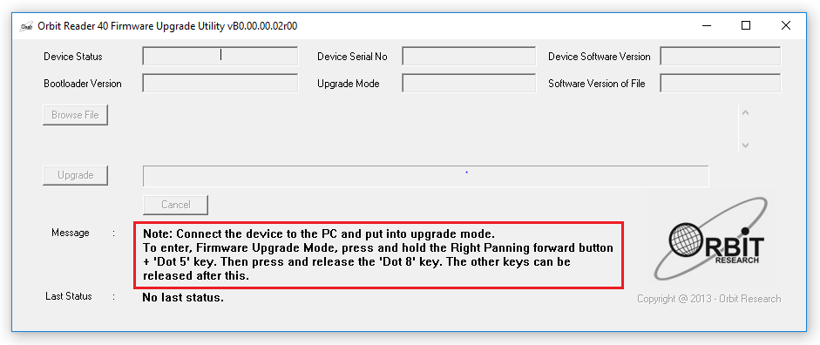

- Press and hold down the Right Pan Lower (RPL) button + Left Pan middle (LPM) key, then press Thumb key 3. The utility shows the message “Orbit Reader 40 is connected” in the Device status field. It shows the message “Do you want to upgrade the device?” in the message field at the bottom of the dialog.
- Release Thumb key 3 first, then release the Right Pan Lower (RPL) key and Left Pan middle (LPM) key. This switches the Orbit Flow 40 to Upgrade mode. You should hear a tone on your PC.
- The utility shows the device serial number and the software version of the device at the top right corner of the window. If the serial number is blank, repeat steps 4 and 5.
- Activate the Browse button found in the dialog.
- Browse and select the firmware bin file from your PC. The file is in the folder you unzipped previously.
- Once the file is selected, the dialog shows the software version of the selected file. A dialog box will also display the information that the current file selected is firmware binary.
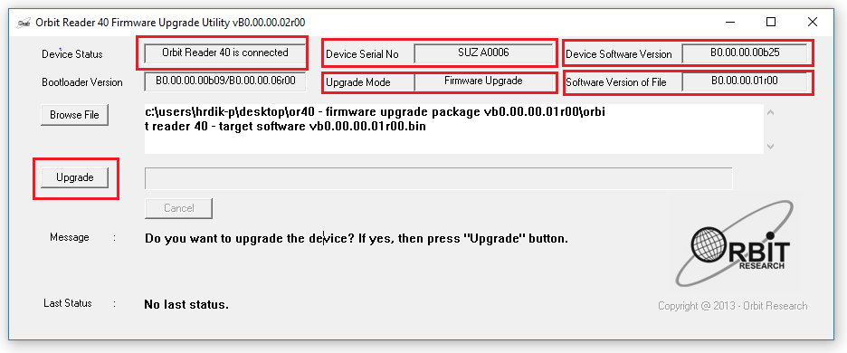

- Activate the Upgrade button. The utility starts upgrading the device. The device will emit a single vibration pulse at 2 second interval.
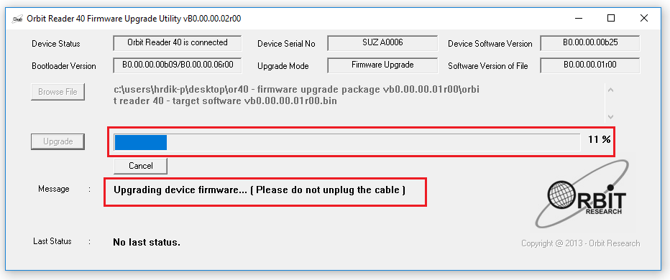
- Do not unplug the cable. Wait for the message “Device upgrade has been completed” on the upgrade utility or until the Orbit Flow 40 reboots and shuts down. Orbit Flow 40 is upgraded.
To check for a successful upgrade of the Orbit Flow 40, press Thumb key 1 + Thumb key 4 to open the Orbit Flow 40 Menu and arrow to "Version" in the list. The version number of the firmware release should match the number shown in the upgrade utility.

Orbit Flow 40 Cleaning Tips
Due to exposure to natural elements such as dust and oils, the Orbit Flow 40 should be cleaned periodically.

The following are some tips to keep your Orbit Flow 40 clean:

- Cleaning should be performed with the unit switched off and with all pins in the down position.
- Use a vacuum cleaner with a soft tip attachment to remove dust from the pin area.
- Use a lint-free cloth to wipe the cells.
- The cloth may be moistened with water.
- Avoid using the following:
- Paper towels, cotton swabs or materials that can release fibers
- Alcohol or ammonia-based cleaners
- Canned or compressed air

General Specifications

- Dimensions (WxHxD): 11.8 x 3.0 x 0.8 inch (30 x 7.7 x 2.0 cm)
- Weight: 0.66 lbs. (300 grams)
- Braille Cells: 40 eight-dot braille cells; Refresh rate < .75 sec
- Input Keys: 4 Thumb keys, Home key, 6 panning keys, rocker type
- OS Support: Windows - NVDA, JAWS, Mac OS X - Voiceover, iOS - Voiceover, Fire OS - VoiceView, Chrome OS - ChromeVox
- Interfaces and Ports: 1x USB Type C port, for host interface, and firmware upgrade
- Environmental Conditions: Operating Temperature: 5 °C to 45 °C, Operating Humidity: 10% - 70% relative humidity, Storage Temperature: -15 °C to 70 °C
- Storage Humidity: 5% - 90% relative humidity

Appendices

Appendix A - Computer Braille Chart
- ASCII Code 33: Exclamation mark, Dots 2-3-4-6
- ASCII Code 34: Quotation marks, Dots 5
- ASCII Code 35: Number sign (Hash), Dots 3-4-5-6
- ASCII Code 36: Dollar sign, Dots 1-2-4-6
- ASCII Code 37: Percentage sign, Dots 1-4-6
- ASCII Code 38: Ampersand, Dots 1-2-3-4-6
- ASCII Code 39: Apostrophe, Dots 3
- ASCII Code 40: Opening round bracket, Dots 1-2-3-5-6
- ASCII Code 41: Closing round bracket, Dots 2-3-4-5-6
- ASCII Code 42: asterisk, Dots 1-6
- ASCII Code 43: Plus sign, Dots 3-4-6
- ASCII Code 44: Comma, Dots 6
- ASCII Code 45: Minus sign, Dots 3-6
- ASCII Code 46: Full stop, Dots 4-6
- ASCII Code 47: Forward Slash, Dots 3-4
- ASCII Code 48: 0, Dots 3-5-6
- ASCII Code 49: 1, Dots 2
- ASCII Code 50: 2, Dots 2-3
- ASCII Code 51: 3, Dots 2-5
- ASCII Code 52: 4, Dots 2-5-6
- ASCII Code 53: 5, Dots 2-6
- ASCII Code 54: 6, Dots 2-3-5
- ASCII Code 55: 7, Dots 2-3-5-6
- ASCII Code 56: 8, Dots 2-3-6
- ASCII Code 57: 9, Dots 3-5
- ASCII Code 58: Colon, Dots 1-5-6
- ASCII Code 59: Semicolon, Dots 5-6
- ASCII Code 60: Opening triangular bracket, Dots 1-2-6
- ASCII Code 61: Equal to sign, Dots 1-2-3-4-5-6
- ASCII Code 62: Closing triangle bracket, Dots 3-4-5
- ASCII Code 63: Question mark, Dots 1-4-5-6
- ASCII Code 64: At sign, Dots 4-7
- ASCII Code 65: A, Dots 1-7
- ASCII Code 66: B, Dots 1-2-7
- ASCII Code 67: C, Dots 1-4-7
- ASCII Code 68: D, Dots 1-4-5-7
- ASCII Code 69: E, Dots 1-5-7
- ASCII Code 70: F, Dots 1-2-4-7
- ASCII Code 71: G, Dots 1-2-4-5-7
- ASCII Code 72: H, Dots 1-2-5-7
- ASCII Code 73: I, Dots 2-4-7
- ASCII Code 74: J, Dots 2-4-5-7
- ASCII Code 75: K, Dots 1-3-7
- ASCII Code 76: L, Dots 1-2-3-7
- ASCII Code 77: M, Dots 1-3-4-7
- ASCII Code 78: N, Dots 1-3-4-5-7
- ASCII Code 79: O, Dots 1-3-5-7
- ASCII Code 80: P, Dots 1-2-3-4-7
- ASCII Code 81: Q, Dots 1-2-3-4-5-7
- ASCII Code 82: R, Dots 1-2-3-5-7
- ASCII Code 83: S, Dots 2-3-4-7
- ASCII Code 84: T, Dots 2-3-4-5-7
- ASCII Code 85: U, Dots 1-3-6-7
- ASCII Code 86: V, Dots 1-2-3-6-7
- ASCII Code 87: W, Dots 2-4-5-6-7
- ASCII Code 88: X, Dots 1-3-4-6-7
- ASCII Code 89: Y, Dots 1-3-4-5-6-7
- ASCII Code 90: Z, Dots 1-3-5-6-7
- ASCII Code 91: Opening square bracket, Dots 2-4-6-7
- ASCII Code 92: Backward slash, Dots 1-2-5-6-7
- ASCII Code 93: Closing square bracket, Dots 1-2-4-5-6-7
- ASCII Code 94: Caret, Dots 4-5-7
- ASCII Code 95: dash, Dots 4-5-6
- ASCII Code 96: backtick sign, Dots 4
- ASCII Code 97: a, Dots 1
- ASCII Code 98: b, Dots 1-2
- ASCII Code 99: c, Dots 1-4
- ASCII Code 100: d, Dots 1-4-5
- ASCII Code 101: e, Dots 1-5
- ASCII Code 102: f, Dots 1-2-4
- ASCII Code 103: g, Dots 1-2-4-5
- ASCII Code 104: h, Dots 1-2-5
- ASCII Code 105: I, Dots 2-4
- ASCII Code 106: j, Dots 2-4-5
- ASCII Code 107: k, Dots 1-3
- ASCII Code 108: l, Dots 1-2-3
- ASCII Code 109: m, Dots 1-3-4
- ASCII Code 110: n, Dots 1-3-4-5
- ASCII Code 111: o, Dots 1-3-5
- ASCII Code 112: p, Dots 1-2-3-4
- ASCII Code 113: q, Dots 1-2-3-4-5
- ASCII Code 114: r, Dots 1-2-3-5
- ASCII Code 115: s, Dots 2-3-4
- ASCII Code 116: t, Dots 2-3-4-5
- ASCII Code 117: u, Dots 1-3-6
- ASCII Code 118: v, Dots 1-2-3-6
- ASCII Code 119: w, Dots 2-4-5-6
- ASCII Code 120: x, Dots 1-3-4-6
- ASCII Code 121: y, Dots 1-3-4-5-6
- ASCII Code 122: z, Dots 1-3-5-6
- ASCII Code 123: Opening curly bracket, Dots 2-4-6
- ASCII Code 124: Vertical bar, Dots 1-2-5-6
- ASCII Code 125: Closing curly bracket, Dots 1-2-4-5-6
- ASCII Code 126: Tilde, Dots 4-5
- ASCII Code 127: NULL, Dots 4-5-6

Revision History
Rev. | Date | Description of Changes | Author
0.0 | 20th May 2026 | Created | Vishal

